Please Note – This form should be used to access Physiotherapy for one musculoskeletal complaint/condition. If you are under 16, recently had surgery or have multiple joint or muscle pains or have specific communication issues preventing you completing this form please contact your GP for referral.
First name |  |  |  |  |  |  |  | Title:
Surname
Date of Birth:
Address (Incl. Postcode)
Daytime Telephone Number |  |  |  |  | Email:
GP Name:
GP Address:
Who is completing this form? |  |  | € Myself € Other; relationship to patient: ……………………
Do you require an interpreter? |  |  | € No € Yes Which language:…………..…
Have you been signed off work because of this problem? |  |  | € No € Don’t Work € Yes; how long……….
Are you unable to care for anyone because of this problem? |  |  | € No € Yes
Are you unable to sleep because of this problem? |  |  | € No € Yes … how many nights per week: ……….
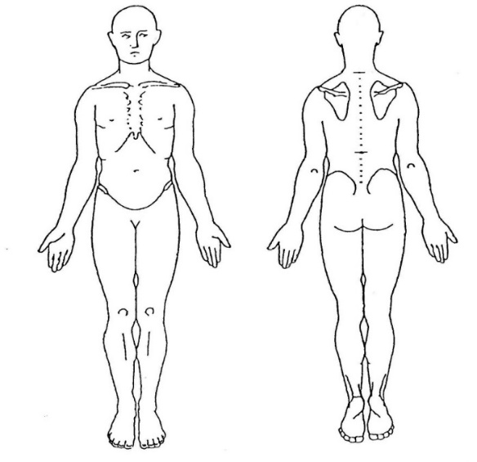
Where is your Problem?
Please write below or indicate on the picture
(NB We can only address one complaint on this form)

Do you have any pins and needles or numbness?
€ No
€ Yes …if so please tell us where:……………………….
How did this start?
What date did this Start?
Has It Changed since it started? |  |  |  | € Better € Worse € The Same
Have you had any treatment for this problem recently or in the past? |  |  |  | € No € Yes Please give details…
Have you seen your GP about this problem |  |  |  | € Yes € No
Name: |  |  |  |  |  | DOB
Please name a daily activity or hobby with which you have difficulty due to your condition and score it in respect to how well or otherwise you can carry them out. 10 able to do without any problem, 0 unable to do them at all.

 | 0 = Unable  to do | 10 = Able to do  as normal
Activity  Eg. Going Up Stairs | 0 1 2 3 4 5 6 7 8 9 10  x
 | 0 1 2 3 4 5 6 7 8 9 10

Relevant medical history; Please tick √ Yes or No for all of the following:
Condition | Yes | No | Have you had any tests for this problem? | Yes | No
Thyroid Problems |  |  | X-ray
Heart Problems |  |  | MRI /CT scan
Family history of Rheumatoid Arthritis |  |  | Ultrasound scan
Epilepsy |  |  | Blood tests
Lung problems |  |  | Other tests
Diabetes |  |  | Please list your current medication
Major Illness |  |  | Have you ever taken steroids?  Have you ever taken blood thinners?
Cancer(Past or Present)
Fractures
Osteoporosis
Do you Smoke?

Only answer these questions if your referral is for a low back problem OR pain in your legs coming from your back, please answer carefully as they relate to important nerves that come from your back and may require your immediate attention.

Since your low back pain started or if it has worsened, please indicate if you have had any changes regarding the following:
- Have you had any loss of sensation or altered sensation in your vaginal / genital area or back passage? (i.e. noticed any changes in sensation when you wipe yourself after going to the toilet OR change in sensation with sexual intercourse)?

- Have you had any change in your bladder or bowel function? (i.e. incontinence or loss of control / increased frequency or being unable to go to the toilet)?

- Have you had any changes in sexual function? (i.e. are you still able to achieve and maintain an erection, do you have normal sensation during sexual intercourse)?

***If You have any of the above you must call 111 or attend A&E IMMEDIATELY***

Please send this completed form to: |  | Email: SC-TR.Coastal-MSK-Physios@nhs.net  Post: Physiotherapy Department, Bognor Regis War Memorial Hospital, Shripney Road, Bognor Regis, PO22 9PP
When using this email address, Sussex Community NHS Trust cannot guarantee the security of this email, or be responsible for the security of any emails once sent or those in the sender's own email inbox. Once received, any personal details contained in this email will remain confidential in accordance with Sussex Community NHS Trust policies and procedures and relevant government legislation

